ME3000PD2 COMBINED CYCLE POWER PLANT
Student Name
Institution
Course Name/Number
Due Date
Instructor Name

DESIGN PROPOSAL
The Combined Cycle Power Plant, otherwise called {CCPP}, is a collection of heat engine motors that cooperate to change heat into mechanical energy from a similar wellspring of heat. A joined cycle gas turbine (CCGT) plant is the most widely recognized gas turbine used to create power on the ground. A blend gas and steam (COGAS) plant, which utilizes a similar idea, is utilized for marine drives. After the main motor has finished its cycle, the hypothesis is that the functioning liquid (fumes) is as yet hot enough briefly heat the motor to get energy from the warmth in the exhaust. The warmth is generally moved through a warmth exchanger, permitting the two motors to utilize separate working liquids.
In this way, the general presentation of consolidating at most minuscule two thermodynamic cycles builds, bringing down fuel costs. To add to that, a joined cycle power plant consolidates a gas and a steam turbine to produce up to half more power from a similar fuel than a regular straightforward cycle plant. The gas turbine's waste warmth is coordinated to a close-by steam turbine, which creates extra power. Also, in 2015, consolidated cycle units represented almost 75% of the all-petroleum gas limit introduced, with an average introduced cost of $614 per kW.
CCPP mainly comprises two force cycles: the Rankine cycle [a steam turbine cycle] and the Brayton cycle [gas turbine cycle]. They are both considered a thermodynamic cycle.
To begin with, Combined Cycle Power Plant, also known as {CCPP}, is a group of heat engines that work together to transform heat into mechanical energy from the same source of heat. A combined cycle gas turbine (CCGT) plant is the most common gas turbine used to generate electricity on the ground. A combination gas and steam (COGAS) plant, which uses the same concept, is used for marine propulsion. The theory is that after the first engine has completed its cycle, the working fluid (exhaust) is still hot enough for a second heat engine to derive energy from the heat in the exhaust. The heat is usually transferred via a heat exchanger, allowing the two engines to use different working fluids.
So, the overall performance of combining two or more thermodynamic cycles increases, lowering fuel costs. To add to that, a combined-cycle power plant combines gas and a steam turbine to generate up to 50% more electricity from the same fuel than a conventional simple-cycle plant. The gas turbine's waste heat moves to nearby steam turbines, which produce additional electricity. Moreover, in 2015, combined-cycle units accounted for nearly 75% of all-natural gas capacity installed, with an average installed cost of $614 per kW.
CCPP mainly consists of two power cycles: the Rankine cycle [a steam turbine cycle] and the Brayton cycle [gas turbine cycle]. They are both considered a thermodynamic cycle.
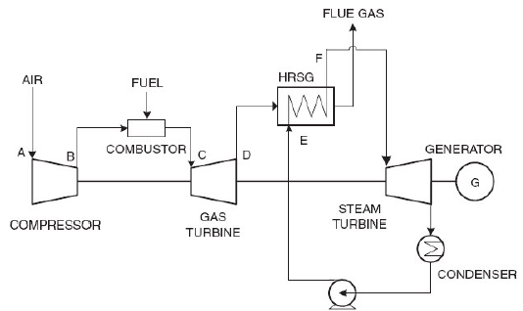

Figure 1: Schematic of combined cycle power plant

In Figure.1, it illustrates the schematic diagram of a combined cycle power plant which explained in the following:
- At A, atmospheric air is compressed in the compressor, and pressurized air (B) is introduced into the GT combustor, mixed with fuel and combustion forms.
- It results in a high-temperature C which enters the gas turbine.
- The temperature of gas turbine exhaust gases (D) is between 500 and 5500 degrees Celsius.
- The heat recovery steam generator (HRSG) utilizes exhaust gases to produce steam using water (E), and the flue gases from the HRSG sent off to the stack. The steam turbine driven by the produced steam (F), and the exhaust from the steam turbine fed to the condenser. The HRSG receives the condensed water again.

In Figure.1, it shows the schematic chart of a joined cycle power plant which will be clarified in these aspects:
• At A, climatic air compacted in the blower and compressed air (B) comes into the GT combustor, blending with fuel and burning structures.
• This brings about a high temperature C which enters the gas turbine.
• The temperature of gas turbine fumes gases (D) is somewhere in the range of 500 and 5500 degrees Celsius.
• The heat recuperation steam generator (HRSG) uses exhaust gases to deliver steam utilizing water (E), and the pipe gases from the HRSG are shipped off to the stack. The steam turbine is driven by the created steam (F), and the exhaust from the steam turbine is taken care of to the condenser. The HRSG gets the dense water once more.

ANALYSIS
The framework's Efficiency (Thermal) is the proportion of the yield work and the heat input showing for ideal situation there ought to be less warmth presented as steam enters the framework while more yield power is created. The way that works yield quickly diminishes contrasted with the warmth input brings about lessening warm proficiency. In this way joining the gas and steam cycles gives the graphical yield beneath at various elevations and surrounding temperature. The efficiency calculations involves determining the potential parameters e.g., pressure, velocity influence for both;
- Brayton Cycle
- Rankine Cycle
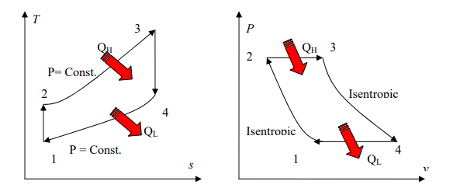
Figure with the Pressure-Velocity Diagram in the Brayton Cycle.
In the Brayton Cycle, outside air enters the blower at a surrounding temperature where its pressing factor and temperature are expanded. The high-pressure air enters the ignition chamber, where the fuel is scorched at a consistent pressing factor. The high temperature (and crucial factor) gas enters the turbine, extending to encompassing critical factors and creating work.
The Brayton ideal cycle has four cycles that are, for the most part, inside reversible (Fig.3):
1. Isentropic pressure 1-2 (in blower)
2. Heat-expansion to 2-3 const. pressure (in the burning chamber)
3. Isentropic extension 3–4 (in the turbine)
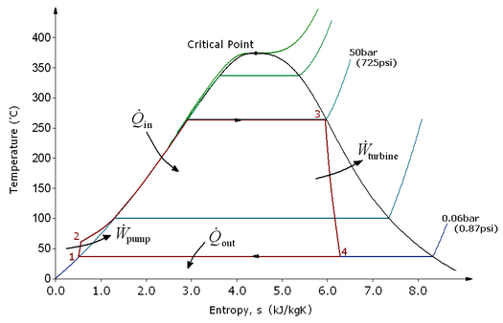

Figure showing the Rankine cycle used in the efficiency calculations.
The Rankine cycle is made of four cycles (Fig.4):
- Process 1–2 (Isentropic pressure): The functioning liquid is siphoned at different pressing factors going from low to high.
- Process 2–3 (Constant pressing factor heat expansion in the heater): The high-pressure fluid arrives at an evaporator and is warmed at a steady pressing factor by an outer warmth source to shape dry soaked fume.
- Process 3–4 (Isentropic development): The dry soaked fume spreads and creates power when it goes through a turbine. The temperature and pressing factor of the fume are decreased; therefore, and some buildup can happen.
- Process 4–1 (Constant pressing factor heat dismissal in the condenser): The wet fume is then aggregated at a consistent pressing factor in a condenser.

DISCUSSION
The benefits of this consolidated cycle power plant; proficiency of the consolidated cycle is higher than different cycles. From the calculated efficiency obtained using the mathematical relationship below the combination of these turbines results to an increase in the efficiency for the various cycles of operations. $$ɳ_{CCPP}=\frac{{Output Work}_{Combined Cycle}}{{Heat Input}_{Gas Turbine}}………….where CCPP=Combined Cycle Power Plant$$
$$ɳ_{CCPP}=\frac{Net Steam Turbine work+Net Gas Turbine Work}{Fuel input Energy into Gas Turbines}$$
Additionally, there is minimal vibration in the system because of the shaft power train in the system architecture, resulting in spiral vibrations. When expressed with vibration vector rotation, it indicates the general stability confirmed with other rotor dynamic investigations. These vibrations contribute to more minor generated friction losses between the static and rotating components in the power plant because of the partial absorption through the shaft, thus increasing the efficiency. Such minimal vibrations contribute to the effectiveness of the power plant in converting the energy from the heat and mechanical energy to electrical energy for distribution that later translates to higher plant profitability. Other deductions from the study are that the power plant; has fewer moving parts making the power plant compact for industrial energy generation, shallow harmful discharges, it can run on various fuels, i.e., complements the thermal and mechanical energy, and has a high working velocity making it fast for electricity generation.

OPTIMAL DESIGN
The ideal power plant should contain an optimal thermal efficiency with less water/air flow rates on the technical performance. The approach of achieving this optimal design includes the support for the Brayton cycle that has a theoretical efficiency equal to 44%. On the economic side, it should have less monetary resources from sourcing the mechanical & electrical components from the procurement process. An approach for meeting this optimal design lies in considering the complexity of this power plant since the more the components, the higher the procurement costs. An example of the Brayton cycle is a higher power-to-weight ratio, indicating the higher profitability from the electricity generated.
In contrast, the weight contribution by the components remains relatively small. Also, the same approach guarantees a higher service life reducing the annual/periodic maintenance costs that negatively affect the long-term profitability of this power plant. Finally, environmental performance should contain minimal environmental waste where the solids should be bio-degradable to minimize endangering terrestrial and aquatic living organisms. Such an approach demands the integration of the Brayton cycle because it allows the inclusion of modern gas turbines that reuses the exhaust gases produced from thermodynamic operation, thus eliminating the chance of air pollution.

CONCLUSION
Thermal efficiency in the power plant lies in expressing the parameters in both the Rankine and Brayton Cycle. This consolidated Cycle Power plant (CCPP) has incredible attainability with the electrical presentation through its enormous scope power age. Its predominant presentation additionally presents an option for the advancement plan to help future forms of the consolidated cycle. This framework has hypothetical effectiveness of 53.5%, with an 8.0% wetness division and a 13% good cutoff that makes it suitable for longer establishment life. The power generated equal to 307.7MW adds to 27% of the current United States introduced limit making it the second-best reasonable option after petroleum gas, higher for choices like Solar and Wind.

REFERENCES
Golebiowski, M., Nordmann, R., & Knopf, E. (2014). Rotordynamic Investigation of Spiral Vibrations: Thermal mode equation development and implementation to the combined-cycle power train. In ASME Turbo Expo 2014: Turbine Technical Conference and Exposition. American Society of Mechanical Engineers Digital Collection.

